

|  |  |  |
| --- | --- | --- |
| **HYDRAULIC VALVES** : We can supply the entire range of reputed brands of Hydraulic & Pneumatic Valves as per requirement e.g. Directional control Valve, Pressure control Valve, Flow Control Valve, Check Valve, Digital Valves, Cartridge Valves, Proportional Valves, Mobile Application Valves, etc.  We have Yuken & Rexroth equivalent Valves.    **HYDRAULIC PUMP** : We can supply all types of hydraulic Pumps like Gear Pump, Vane Pump, Piston Pump, Variable displacement Pumps, Hand Pumps.    **OIL COOLERS AIR TYPE** GEAR COUPLINGS    **BREATHER SUCTION STRAINER**    **OIL LEVEL INDICATOR PRESSURE GAUGE**    **RETURN LINE FILTER HYDRAULIC FITTINGS** | **HYDRAULIC HOSES** SEAL KIT | **JAGDAMBA**  **SHREE JAGDAMBA HYDROPNEUMATIC INC**      **INNOVATIVE PRODUCTS FOR**  **PRODUCTIVITY PERFORMANCE &**  **PROFITABILITY** |
|  |
| HONED TUBE **HARD CHROME PLATED ROD** |
|  |
| **"We undertake job work of honing for new & old cylinder"** |
| ABOUT US |
| **Shree Jagadamba Hydraupneumatic Inc.** is technocrat |
| company, can offer complete Hydro-Pneumatic solution and is |
| in business of manufacturing & servicing of Hydraulic and |
| Pneumatic Cylinders, Hydraulic Power Packs, Manifold Blocks, |
| Hydraulic Presses, Hydraulic accessories, Special purpose |
| machines & consultancy. |
| We are specialized in developing import substitute |
| products, having excellent understanding in hydrauIic/ |
| pneumatic technology with strength of around 20 Years. We are |
| continuously striving to produce the reliable products range |
| with best quality. Customer satisfaction is our main aim. |
| We have a state of art manufacturing facility at MIDC, |
| Butibori, Nagpur. |
| We are distributor of Jaichamundi Tech Pvt. Ltd., |
| Bangalore. For valves, Pumps Ac / Dc Mobile Power Packs, |
| Cartridge Valves, Manifold Blocks, Walking Floors & |
| other products. |
| **MAJOR CLIENTS** : |
| * MAHAGENCO • WCL • MOIL • SUNFLAG STEEL • BALCO • L&T |
| SO MANY EQUIPMENT MANUFACTURERS. |
| **SHREE JAGDAMBA HYDROPNEUMATIC INC** |
| Factory : Plot No. A-11/21 MIDC, Butibori, Tah. Hingna, |
| Dist, Nagpur-441122. State: Maharashtra India. |
| Cell : +91 9372072041, +91 9372072042 |
| E-mail: [info_hydropneumatics@yahoo.com](mailto:info_hydropneumatics@yahoo.com) |
| Web: [www.indiamart.com/jagdambahydro/](http://www.indiamart.com/jagdambahydro/) |
| GST 27ABHFS2192P1ZH |

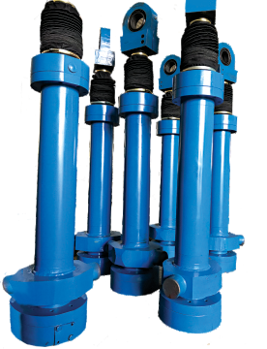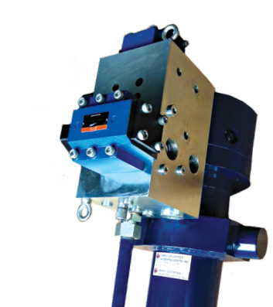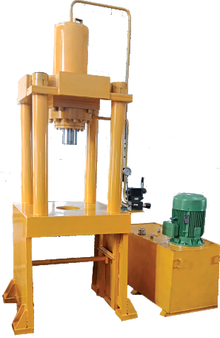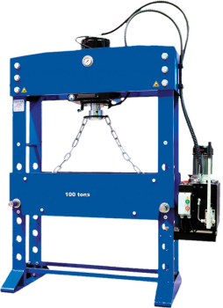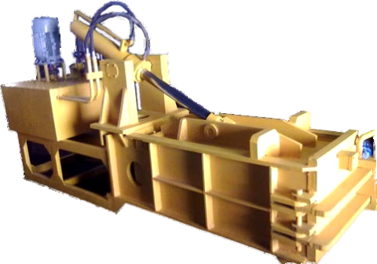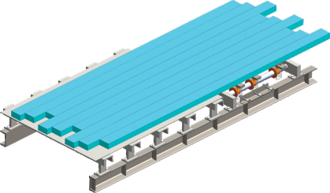

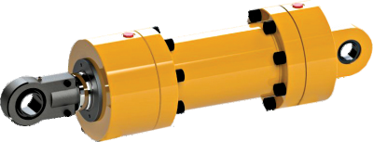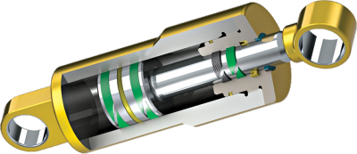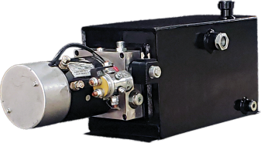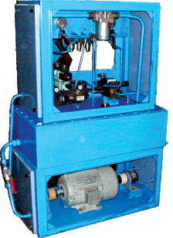

|  |  |  |
| --- | --- | --- |
| We manufacture Medium duty, Heavy duty, Mill duty, Tie rod construction, Telescopic & Custom design cylinder.  We offer complete solution, our designed and manufactured cylinders that are suit to any mobile or industrial application or to meet desired specifications.  Our extensive product line offers OEM's and suited to any end users hydraulic cylinder solutions that provide value through reduced maintenance, increased productivity, and long service life.  We offer wide range of hydraulic power packs which can be used in lifting platforms, elevators, wagon tipplers, hydraulic presses, machine tools and mobile applications. We ensure cost effective products witho ut compromising there quality.    We offer manifold blocks of various designs, different sizes and frameworks right from the smallest of the unit to large hydraulic manifolds that form ofa huge hydraulic system.  We are specialized in designing developing & manufacturing the manifolds as per customers requirements. We can replace existing OEM manifolds with cost effective quality products.  We have a standard range of manifold bIoc ks li ke • Lift BIo ck • P CM BI ock   * Regeneration Block • Sequence Block • 1,2,3 & 4 Station Block. | We manufacture wide range of Hydraulic operated presses for various applications. Our presses are precisely fabricated & machined for its optimum performance at low maintenance cost.  **Applications** • Work Shop Press • Scrape Bailing Press (Metal/PIastic/ Paper) • Deep Draw Press   * Special Purpose Press • Sheet Metal Press * Stamping Press • Lamination Press.   Work Shop Press  Scrape Bailing Press  Special Purpose Press    Deep Draw Press | These are specially designed hydraulic operated gates used for warehouses, factories. These gates are the replacement to traditional large opening shutters. These gates are easy to install and operate, with all safety features. In case of power failure these can be operated manually also.    Walking floor is a hydraulically-driven moving-floor conveyance system for moving bulk material or pelletized product, which can be used in a warehouse, loading dock or semi-trailer.  The moving floor is divided into three sets of narrow floor slats, with every third slat connected together, hydraulically powered to move forward and backward either in unison, or alternately. When all three sets move in unison, the load is moved upon them in the direction the operator wishes. |